**Capstone Design(2)**

**Proposal**



**Subjects : Capstone Design(2)**

**Prof. : Sang O Park**

**Team Name : 316**

**Members : 20163704 Park Juhyeon**

**20161344 Heo JeongWoo**

**20164245 Hong Jin**

1. **Project Title**

Project Title : Smoothie

“Smoothie” is a Photo Edit Program,

We select this project’s title to emphasize feeling of ‘Smooth’.

1. **Introduction & Motivation**

Sometimes, we need to edit photos. In particular, we must extract and copy or delete certain objects shown in the photos. However, there are many inconveniences in the process of extracting objects and in using extracted objects.

First, it is inconvenient to extract the objects. Even if program cut it automatically, it is not accurate and requires a lot of modifications.

Second, if we work with multiple photos, we need to do a lot of similar tasks.

So, we will develop some photo edit program named "Smoothie". If users want to extract same object in multiple photos, users can use our program to open multiple photos and enter the object name. Then "Smoothie" extracts object in photos that user opened, and user uses that freely.

So, with our "Smoothie", users can avoid tedious repetitive tasks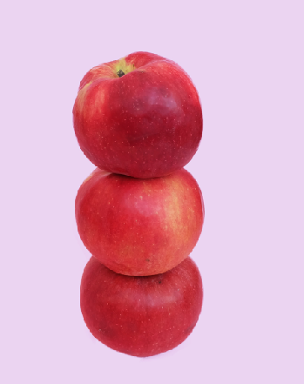 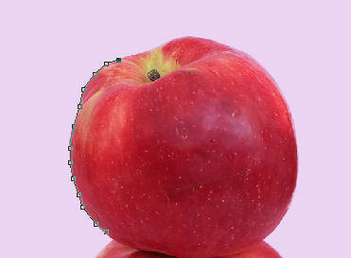

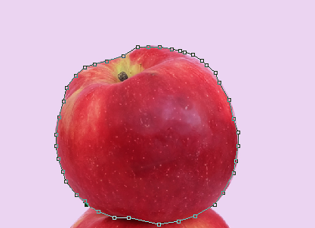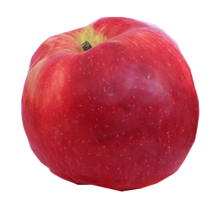

1. **Development & Implementation Contents**

* **Lasso Function**
* Show areas of snails based on learning data.
* Provides a convenient way to use by displaying a small number of points (approximately 3,4).
* Learning from a variety of data sets (released in detail later)
* **Lasso Function**
* Develop image editing programs using Qt
* Develops other useful features such as layers, paints, brushes, trims, resizing, spades, text, erasers, etc.
* **Error Minimization With TDD**
* Recognized the importance of error minimization through last Capstone design class.
* We will try to minimize errors by writing as many TCs as possible with TDD.
* We will open TC often.

1. **Goal**
2. Improve the speed and accuracy of the Lasso function.
3. Provide a variety of image editing functions
4. Minimize program errors

Our goal is developing simple photoshop program using Qt.

The main function is to apply ML to the lasso function to recognize a specific image area through four user-selected points, and to separate that area from the background layer so that users can edit it freely.

1. **Roles**

Park Juhyeon

-Collect Running Datasets

-Implementing a Learning Model

-Layer Function Implementation

-Test

Heo JeongWoo

* + Collecting Running Datasets
  + Implementing a Learning Model
  + Implementing sizing
  + Test

Hong Jin

-Collecting Running Datasets

-Learning data to model

-Implementing Qt UI and basic functions

-Test

1. **Market Research**

1. Photoshop

- Point by point to draw out an object.

- Not only is it taking a long time, and it takes a lot of hands, the results also differ depending on individual ability

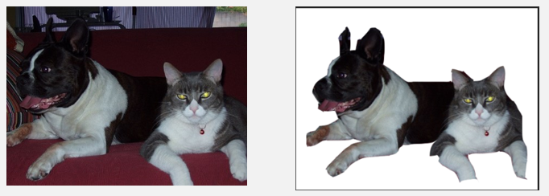

2. Remove.bg

-Free.

-Use background erasing method**.**

-Unable to set the desired part and only people can be recognized

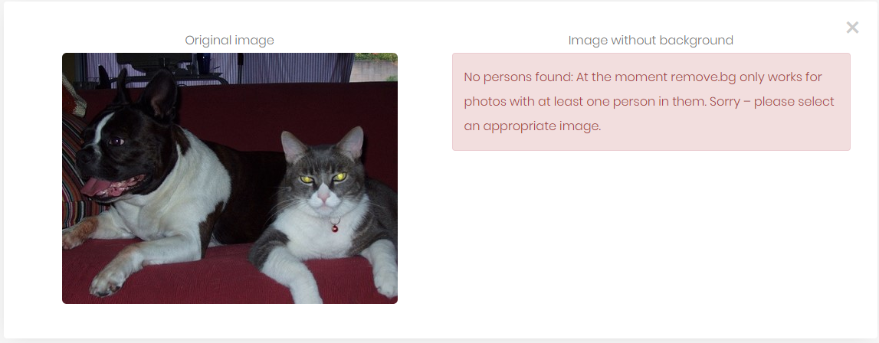

3. Photopea

-Free.

-Provide basic image editing functions in Web.

-Magnetic Lasso function exists but it’s too weak.

-Ads appear often.

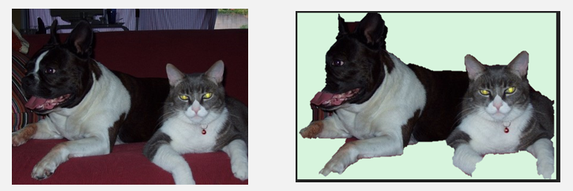



4. BackGround Burner

-Remove background by separating regions in two colors**.**

-Good performance for simple images, but not for complex images**.**

-It can’t be edited and only available as JPG, PNG.

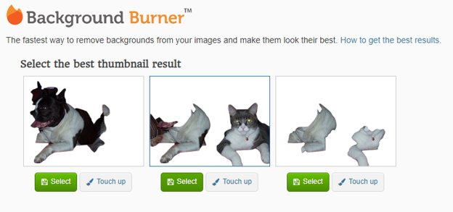

5. PowerPoint

-PowerPoint offers ‘background remove’ function

-free

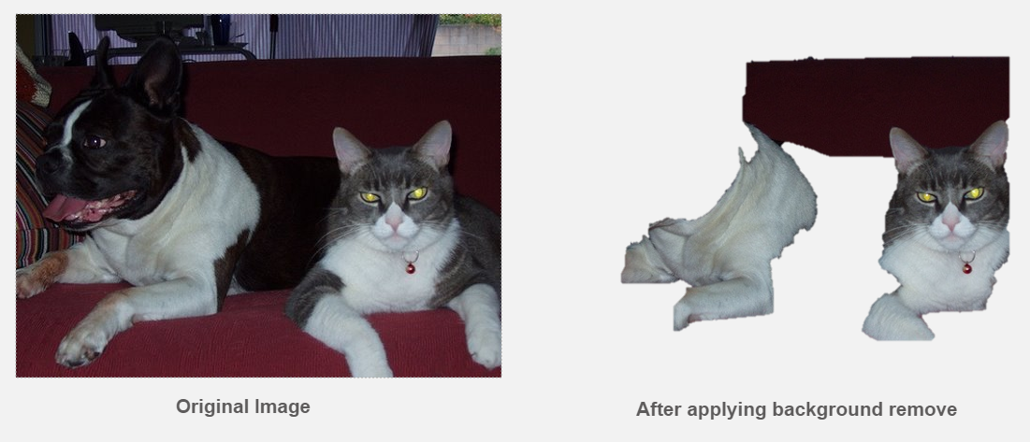

**7. Project Schedule.**

|  |  |  |  |  |  |  |  |  |  |  |  |  |  |  |  |
| --- | --- | --- | --- | --- | --- | --- | --- | --- | --- | --- | --- | --- | --- | --- | --- |
|  | March | | | April | | | | | May | | | | June | | |
| Development Contents | 11 | 18 | 25 | 1 | 8 | 15 | 22 | 29 | 6 | 13 | 20 | 27 | 3 | 10 | 17 |
| Content Acquisition &  Data Survey |  |  |  |  |  | Midterm Demonstration and Presentation |  |  |  |  |  |  | Final Demonstration and Presentation |  |  |
| Collect Initial Usage Datasets |  |  |  |  |  |  |  |  |  |  |  |  |  |
| Implementing a Deep Learning Model |  |  |  |  |  |  |  |  |  |  |  |  |  |
| Check the Results of Learning |  |  |  |  |  |  |  |  |  |  |  |  |  |
| Oligami Functional Test |  |  |  |  |  |  |  |  |  |  |  |  |  |
| Implementing layer editing |  |  |  |  |  |  |  |  |  |  |  |  |  |
| Preparing Midterm Demonstration and Presentation |  |  |  |  |  |  |  |  |  |  |  |  |  |
| Implementing other editing functions |  |  |  |  |  |  |  |  |  |  |  |  |  |
| Test and Debugging |  |  |  |  |  |  |  |  |  |  |  |  |  |
| Preparing Final Demonstration and Presentation |  |  |  |  |  |  |  |  |  |  |  |  |  |
| Writing manuals and reports |  |  |  |  |  |  |  |  |  |  |  |  |  |

* Park Juhyeon`s Schedule

|  |  |  |  |  |  |  |  |  |  |  |  |  |  |  |  |
| --- | --- | --- | --- | --- | --- | --- | --- | --- | --- | --- | --- | --- | --- | --- | --- |
|  | March | | | April | | | | | May | | | | June | | |
| Development Contents | 11 | 18 | 25 | 1 | 8 | 15 | 22 | 29 | 6 | 13 | 20 | 27 | 3 | 10 | 17 |
| Content Acquisition &  Data Survey |  |  |  |  |  | Midterm Demonstration and Presentation |  |  |  |  |  |  | Final Demonstration and Presentation |  |  |
| Collect Initial Usage Datasets |  |  |  |  |  |  |  |  |  |  |  |  |  |
| Implementing a Deep Learning Model |  |  |  |  |  |  |  |  |  |  |  |  |  |
| Implementing layer editing |  |  |  |  |  |  |  |  |  |  |  |  |  |
| Preparing Midterm Demonstration and Presentation |  |  |  |  |  |  |  |  |  |  |  |  |  |
| Test and Debugging |  |  |  |  |  |  |  |  |  |  |  |  |  |
| Preparing Final Demonstration and Presentation |  |  |  |  |  |  |  |  |  |  |  |  |  |
| Writing manuals and reports |  |  |  |  |  |  |  |  |  |  |  |  |  |

* Heo JeongWoo`s Schedule

|  |  |  |  |  |  |  |  |  |  |  |  |  |  |  |  |
| --- | --- | --- | --- | --- | --- | --- | --- | --- | --- | --- | --- | --- | --- | --- | --- |
|  | March | | | April | | | | | May | | | | June | | |
| Development Contents | 11 | 18 | 25 | 1 | 8 | 15 | 22 | 29 | 6 | 13 | 20 | 27 | 3 | 10 | 17 |
| Content Acquisition &  Data Survey |  |  |  |  |  | Midterm Demonstration and Presentation |  |  |  |  |  |  | Final Demonstration and Presentation |  |  |
| Collect Initial Usage Datasets |  |  |  |  |  |  |  |  |  |  |  |  |  |
| Implementing a Deep Learning Model |  |  |  |  |  |  |  |  |  |  |  |  |  |
| Oligami Functional Test |  |  |  |  |  |  |  |  |  |  |  |  |  |
| Preparing Midterm Demonstration and Presentation |  |  |  |  |  |  |  |  |  |  |  |  |  |
| Implementing other editing functions |  |  |  |  |  |  |  |  |  |  |  |  |  |
| Test and Debugging |  |  |  |  |  |  |  |  |  |  |  |  |  |
| Preparing Final Demonstration and Presentation |  |  |  |  |  |  |  |  |  |  |  |  |  |
| Writing manuals and reports |  |  |  |  |  |  |  |  |  |  |  |  |  |

* Hong Jin`s Schedule

|  |  |  |  |  |  |  |  |  |  |  |  |  |  |  |  |
| --- | --- | --- | --- | --- | --- | --- | --- | --- | --- | --- | --- | --- | --- | --- | --- |
|  | March | | | April | | | | | May | | | | June | | |
| Development Contents | 11 | 18 | 25 | 1 | 8 | 15 | 22 | 29 | 6 | 13 | 20 | 27 | 3 | 10 | 17 |
| Content Acquisition &  Data Survey |  |  |  |  |  | Midterm Demonstration and Presentation |  |  |  |  |  |  | Final Demonstration and Presentation |  |  |
| Collect Initial Usage Datasets |  |  |  |  |  |  |  |  |  |  |  |  |  |
| Check the Results of Learning |  |  |  |  |  |  |  |  |  |  |  |  |  |
| Oligami Functional Test |  |  |  |  |  |  |  |  |  |  |  |  |  |
| Preparing Midterm Demonstration and Presentation |  |  |  |  |  |  |  |  |  |  |  |  |  |
| Implementing other editing functions |  |  |  |  |  |  |  |  |  |  |  |  |  |
| Test and Debugging |  |  |  |  |  |  |  |  |  |  |  |  |  |
| Preparing Final Demonstration and Presentation |  |  |  |  |  |  |  |  |  |  |  |  |  |
| Writing manuals and reports |  |  |  |  |  |  |  |  |  |  |  |  |  |